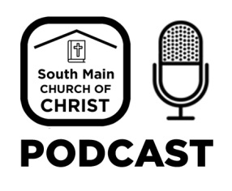

Topic | Guest(s)
Providence | Mark Tonkery
I Corinthians 15:1 Paul declares the Gospel | Mark Tonkery
“In Christ”: Making a Commitment | Mark Tonkery
Ladies Inspiration Day - Coincidences | Laura Tonkery & Jackie Jadwin

